**Title:**

**Cascading Style Sheet - To apply the 3 types of CSS style sheet and the different types of selectors used.**

**Objective(s):**

At the end of these lessons, students will be able to.

• Apply the 3 types of CSS style sheet and the use of selectors in CSS.

**Tools, Equipment and Materials:**

1. Personal Computer with Internet access
2. Web Authoring Tool (Adobe Dreamweaver CC) or Visual Studio Code
3. Web Browser

**Instructions:**

# Part (A) – Understanding Style Sheets

**What is CSS?**

**Module Code**

IT43004FP

**Duration**

3

hours

**Module**

Front-end

Web

Development

* CSS stands for Cascading Style Sheets
* CSS describes how HTML elements are to be displayed on screen, paper or in other media.
* CSS saves a lot of work. It can control the layout of multiple web pages all at once.
* External style sheets are saved in .css files.

# CSS syntax

A CSS rule-set consists of a selector and a declaration block:

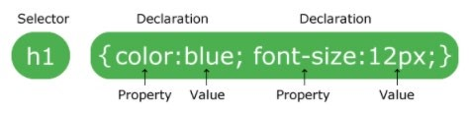

* The selector points to the HTML element you want to style.
* The declaration block contains one or more declarations separated by semicolons.
* Each declaration includes a CSS property name and a rule, separated by a colon.
* A CSS declaration always ends with a semicolon, and declaration blocks are surrounded by curly braces.

**There are three ways to define / insert style:**

* External style sheet
* Internal style sheet
* Inline style sheet

# External style sheet

With an external style sheet, you can change the look of an entire website by changing just one file!

Each page must include a reference to the external style sheet file inside the <link> element. The <link> element goes inside the <head> section:

1. Create a new folder on Desktop and name it as IndexNo_YourName_Lab07a.

1. Create a new site in Dreamweaver and name it as Lab07a_YourName as well. Browse the local site folder to the folder you have just created on Desktop.

**Module Code**

IT43004FP

**Duration**

3

hours

**Module**

Front-end

Web

Development

1. Create a new HTML document and save it as **external_css.html**

1. Type the following HTML code within the <body> </body> tags and “HTML with external CSS” in the <title> tag:

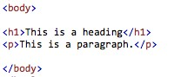

**Module Code**

IT43004FP

**Duration**

3

hours

**Module**

Front-end

Web

Development

**Sample Output with browser defaults (without CSS):**

5

.

Now let’s style externalcss.html using external CSS. Create a new

CSS file using Visual Studio Code:

File

→

New File

→

You will see a new and blank file as shown.

Save the file as

**styles.css**

.

6

Add the following styles to style.css file.



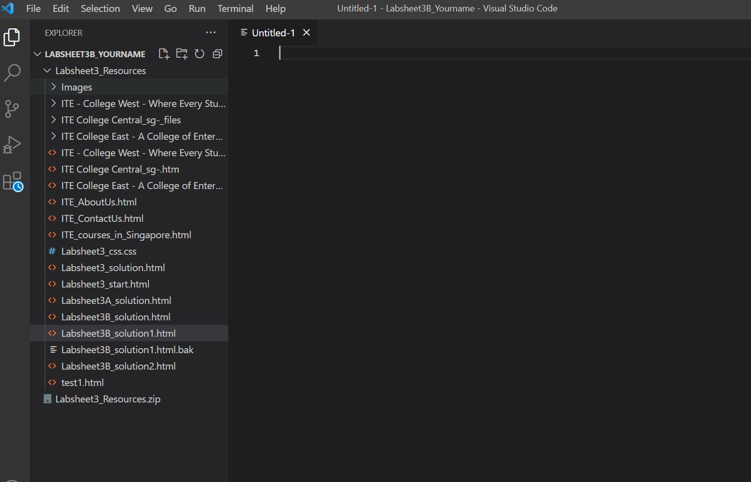

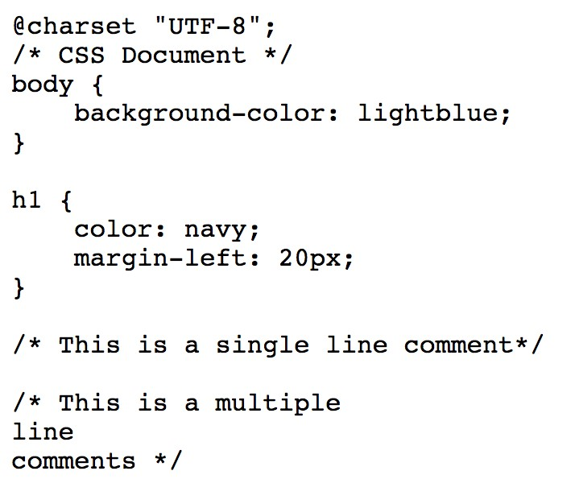

7 To link the external style sheet to the HTML document, use the <link> element. Type the following in the <head> section of the HTML document:

**Module Code**

IT43004FP

**Duration**

3

hours

**Module**

Front-end

Web

Development

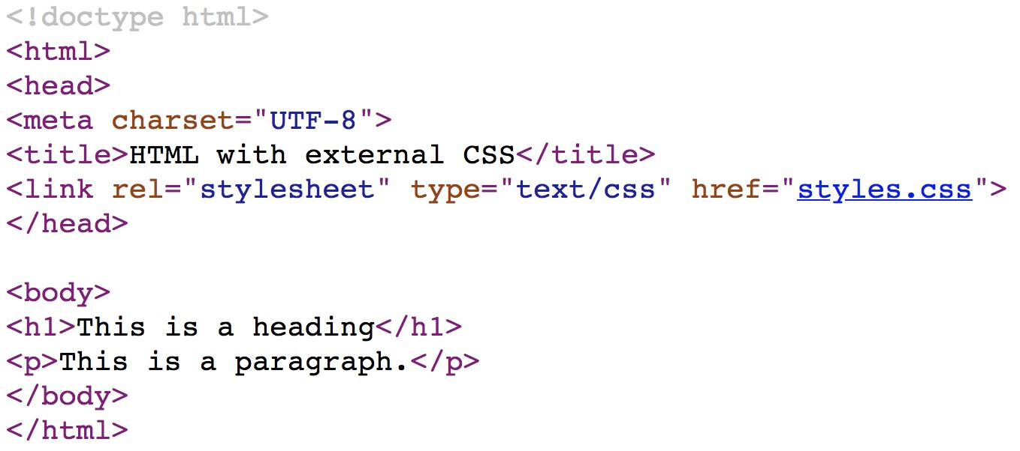

**Sample output (with external CSS):**



Note that the styles in the external CSS have taken place and changed the look of the web page.

**Part (B) Internal Style Sheet**

An internal style sheet may be used if **one single page** has a unique style. Internal styles are defined within the <style> element, inside the <head> section of an HTML page.

1. Create a new HTML document and save it as **internal_css.html**

1. Type the following HTML code within the <body> </body> tags and type “HTML with internal CSS” in the <title> tag:

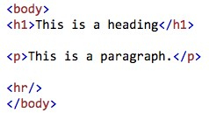

1. Let’s style internlcss.html with internal CSS now. In the <head> section, type the following:

**Module Code**

IT43004FP

**Duration**

3

hours

**Module**

Front-end

Web

Development

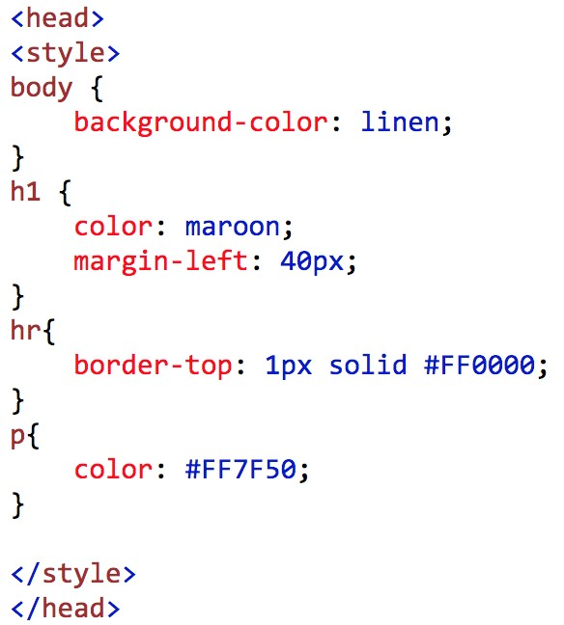

**Module Code**

IT43004FP

**Duration**

3

hours

**Module**

Front-end

Web

Development

**Output sample (with internal CSS):**

**Inline Style:**

An inline style may be used to apply a unique style for a single element.

To use inline styles, add the style attribute to the relevant element. The style

attribute can contain any CSS property.

1

Create a new HTML document and save it as

**inline_css.html**

.

2

Type the following to style a particular <p> element using inline CSS

:

Sample Output:

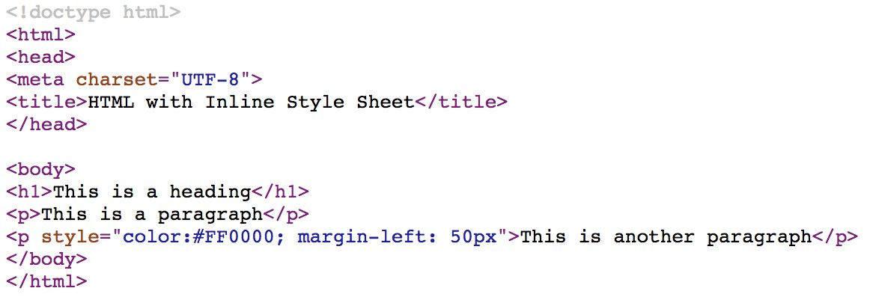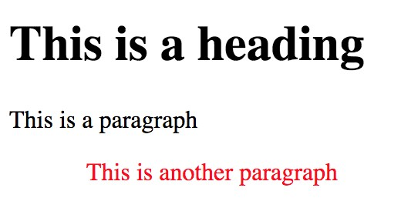

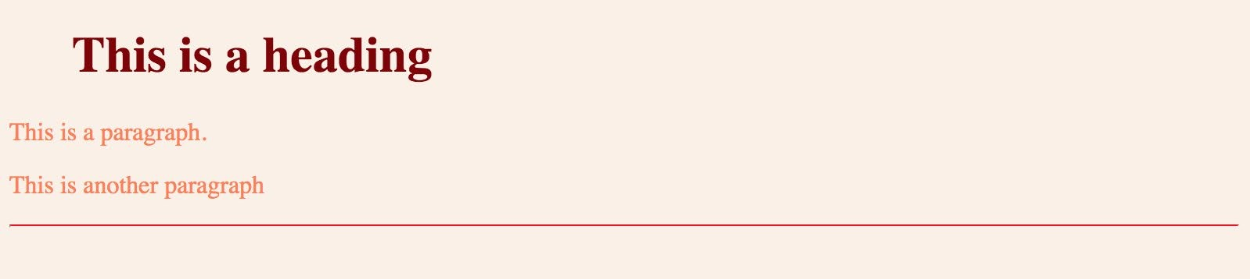

# Cascading Order

What style will be used when there is more than one style specified for an HTML element?

Generally speaking we can say that all the styles will "cascade" into a new "virtual" style sheet by the following rules, where number one has the highest priority:

1. Inline style (inside an HTML element)

1. External and internal style sheets (in the head section)

1. Browser default

So, an inline style (inside a specific HTML element) has the highest priority, which means that it will override a style defined inside the <head> tag, or in an external style sheet, or a browser default value.

1. Create a new HTML document and save it as **css_order.html**.

1. Type the following:

**Module Code**

IT43004FP

**Duration**

3

hours

**Module**

Front-end

Web

Development

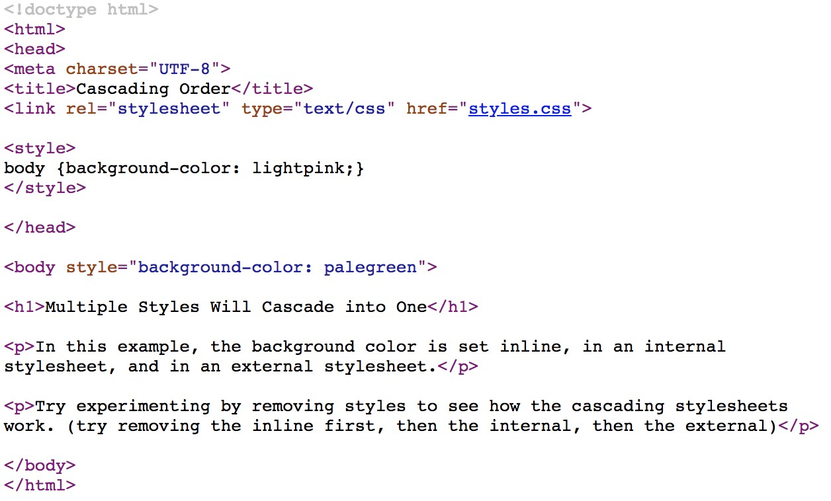

External CSS

(

created earlier)

Inline CSS

Internal CSS

**Module Code**

IT43004FP

**Duration**

3

hours

**Module**

Front-end

Web

Development

**Sample output:**

**Why the above web page appeared as such?**

3

Now, let’s remove the inline css: <body style="background-color: palegreen"

>

from the <body> tag.

4

Preview the HTML document in the browser. Screen capture the

browser output display below:

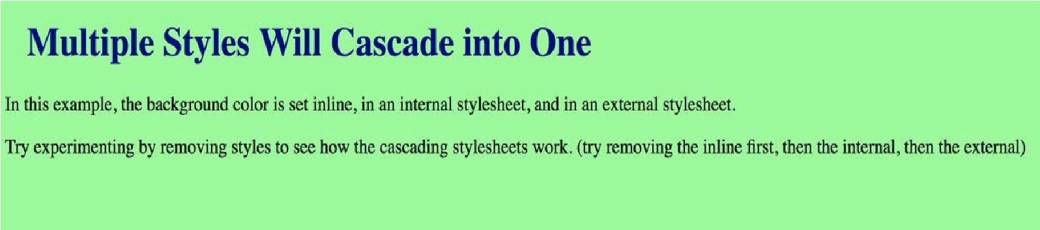

# The id Selector

The id selector uses the id attribute of an HTML element to select a specific element.

The id of an element should be unique within a page, so the id selector is used to select one unique element!

To select an element with a specific id, write a hash (#) character, followed by the id of the element.

1. Create a new HTML document and save it as **id_selector.html**

1. Type the following internal CSS in the <head> section, HTML code within the <body> </body> tags and “CSS with id selector” in the <title> tag:

**Module Code**

IT43004FP

**Duration**

3

hours

**Module**

Front-end

Web

Development

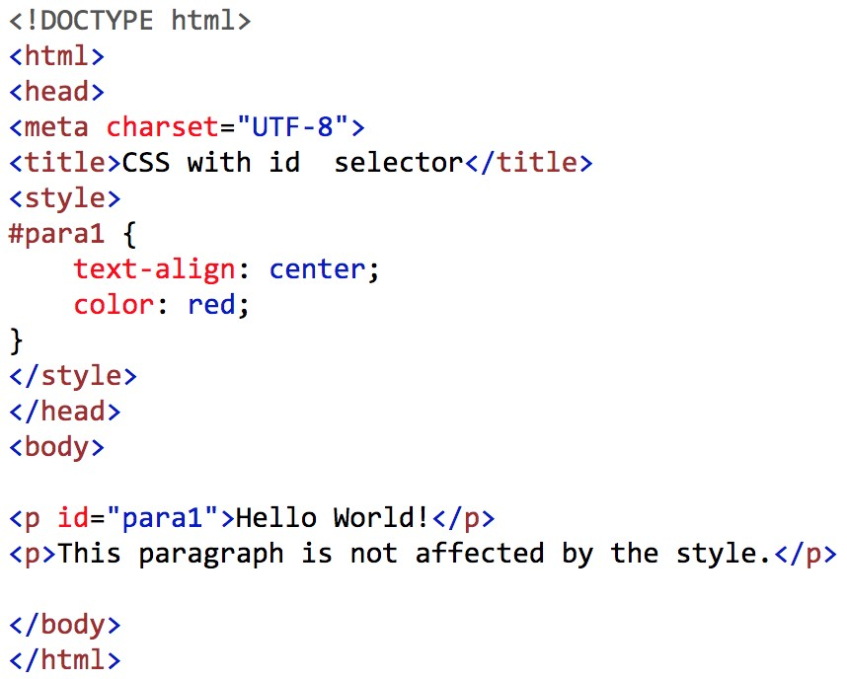

**Sample output:**



# The class Selector

The class selector selects elements with a specific class attribute.

To select elements with a specific class, write a period (.) character, followed by the name of the class.

In the example below, all HTML elements with class="center" will be red and center-aligned:

1. Create a new HTML document and save it as **class_selector.html**

1. Type the following internal CSS in the <head> section, HTML code within the <body> </body> tags and “CSS with Class Selector” in the <title> tag:

**Module Code**

IT43004FP

**Duration**

3

hours

**Module**

Front-end

Web

Development

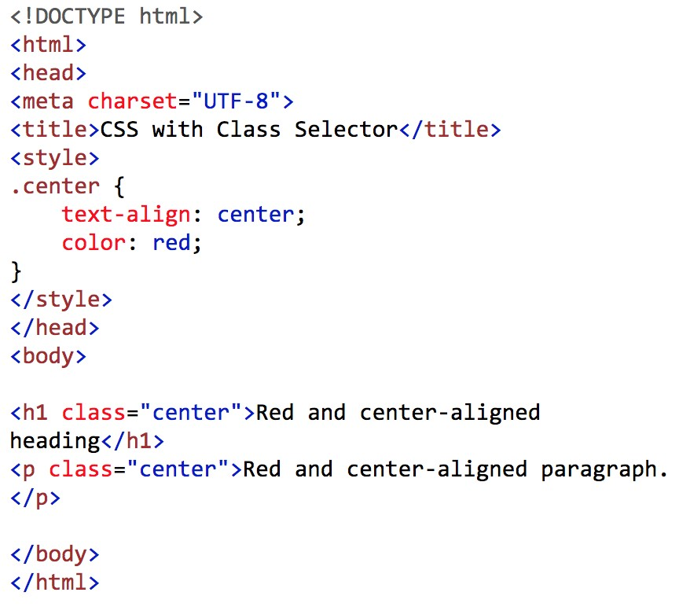

**Sample Output:**

**Module Code**

IT43004FP

**Duration**

3

hours

**Module**

Front-end

Web

Development

**Grouping Selectors**

If you have elements with the same style definitions, like this:

It will be better to group the selectors, to minimize the code. To group

selectors, separate each selector with a comma.

In the example below we have grouped the selectors from the code above:

1

Create a new HTML document and save it as

**grouping_selector.html**

Type the following internal CSS in the <head> section, HTML code

2

within

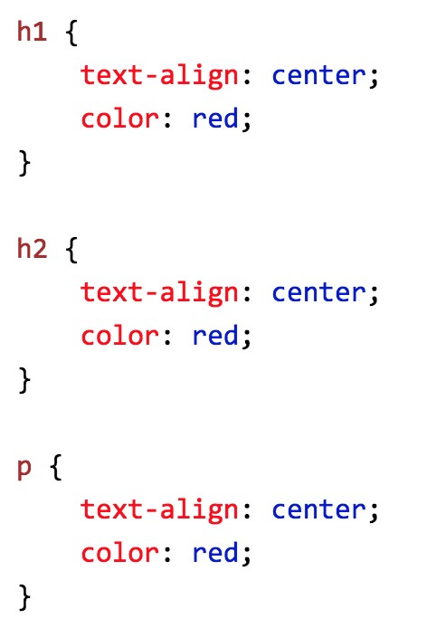



**Module Code**

IT43004FP

**Duration**

3

hours

**Module**

Front-end

Web

Development

the <body></body> tags and “CSS with group Selector” in the <title>

tag:

**Sample output:**

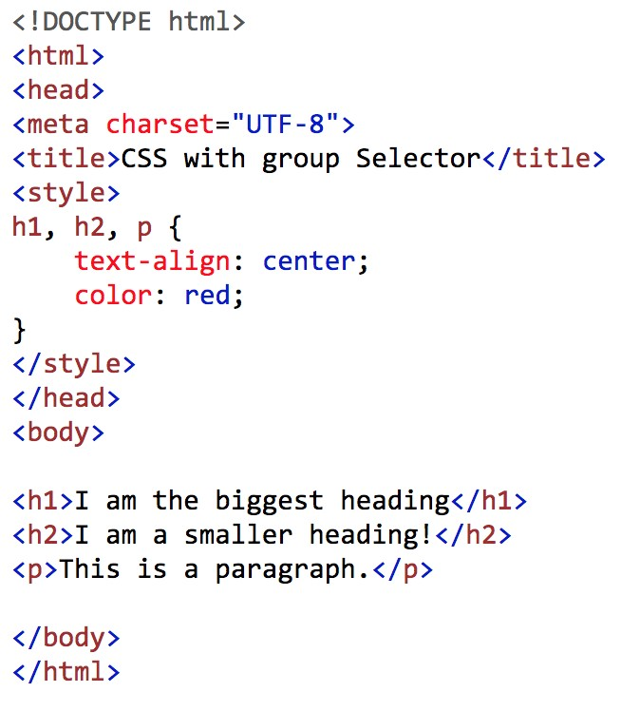

**Module Code**

IT43004FP

**Duration**

3

hours

**Module**

Front-end

Web

Development

-

END -

Submitted by:

Name: ___Joshua Chan_______________________________

Class: ____CC2201F______________________________

*E 2021*